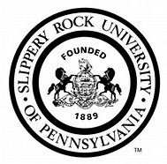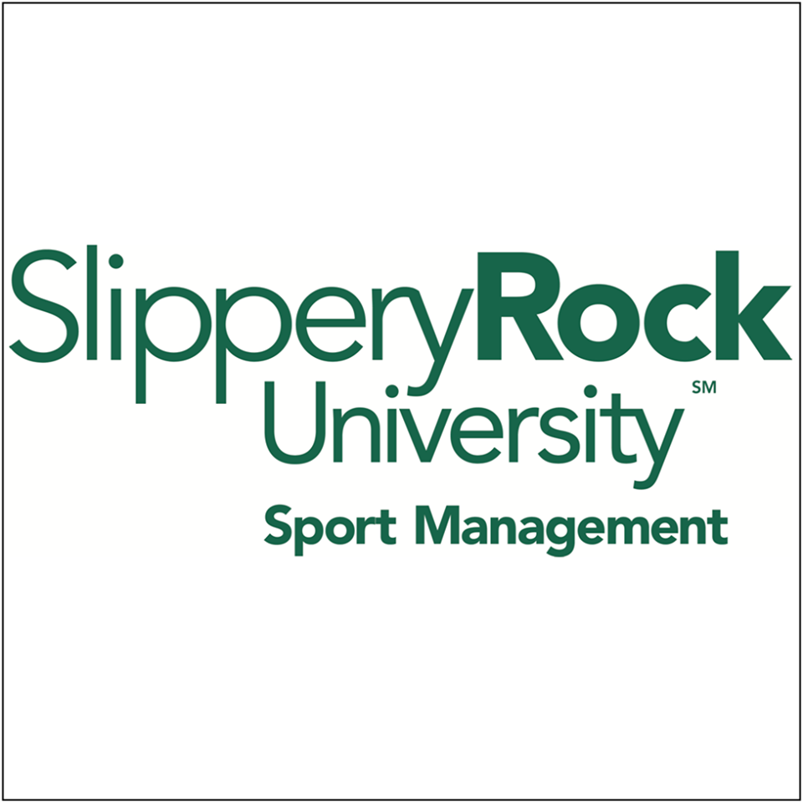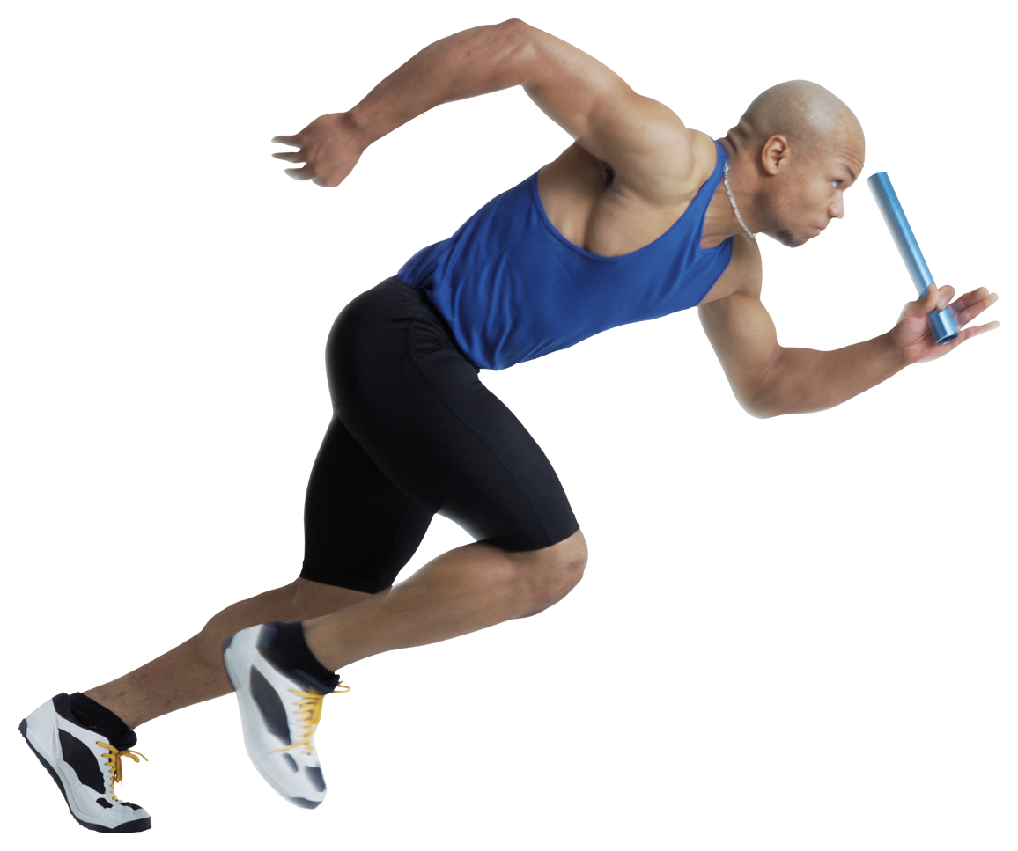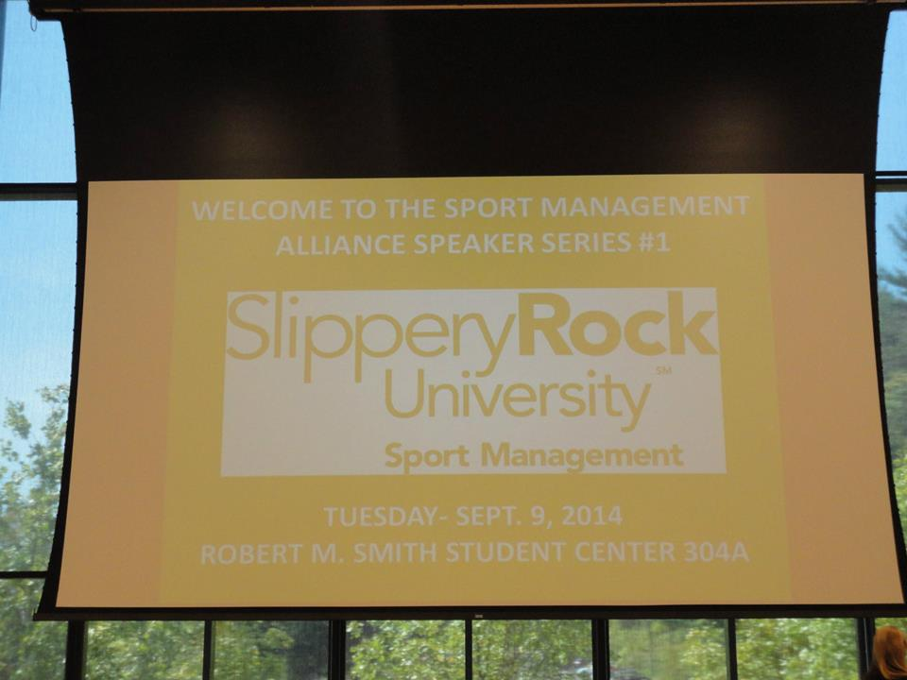

Sport management At slippery rock university

* The program began at Slippery Rock in 1977. This program can offer numerous career opportunities for graduates such as getting a career in the sport field that they love.
* Students are required four internships as a major for Sport Management over the four years attending the program and one as a minor.
* Students are required a minimum of 120 hours of volunteer work for four years. Of course, many students have more than the required hours.

# Program History, Credentials and Volunteer Hour Requirements

Location: 101 Eisenberg Classroom Bldg, E Loop, Slippery Rock, Pennsylvania 16057

Phone: 724-738-2060

Faculty and Staff: Dr. Robertha Abney, Dr. Catriona Higgs and Dr. Benjamin Wright (filling in for Dr. Crow who is on sebatical)

Social Media Websites:

Facebook (SRU Sport Management)

Twitter (@SRUSPMT)

Instagram (@sruspmt)

Linkedin: SRU Sport Management

Events:

Special Olympics

Sport Management Banquet

Sport Management Alliance (SMA) monthly meetings

Robert Morris Conference

Sport Management Picnic

Events and social Media

# Sport Management Department

* Slippery Rock is accredited by the Commission on Sport Management Accreditation (COSMA)
* First program in U.S. to receive this accreditation in the year 2010.
* Reputation of one of the best undergraduate programs in the nation.

Citations: SRU Sport Management Facebook, SRU website, Sport Management Department

-Sport Management Bulletin Board

“Choose a job you love and you will never have to work a day in your life”

Some jobs that graduates have received in the past are:

* Operations Director for major league soccer
* Assistant Athletic Director for Development at UNM Lobo Club
* Manager for Event Services for the Charlotte Bobcats

# Job Opportunities

2014-2015

President: Jordan Woyt

Vice President: Eliza Sykes

Business Expansion Chair: Alexandra Wenrich

Development Chair: Christopher King

Industry Relations Chair: Mckenzie Popatak

Social Media Chair: Carlyne DeRose

Web Manager: Paige Constantino

PrPresiednt e

**SMA (Sport Management Alliance) Board Members**

# Fun Facts